Faculty Name : Sonam Angmo
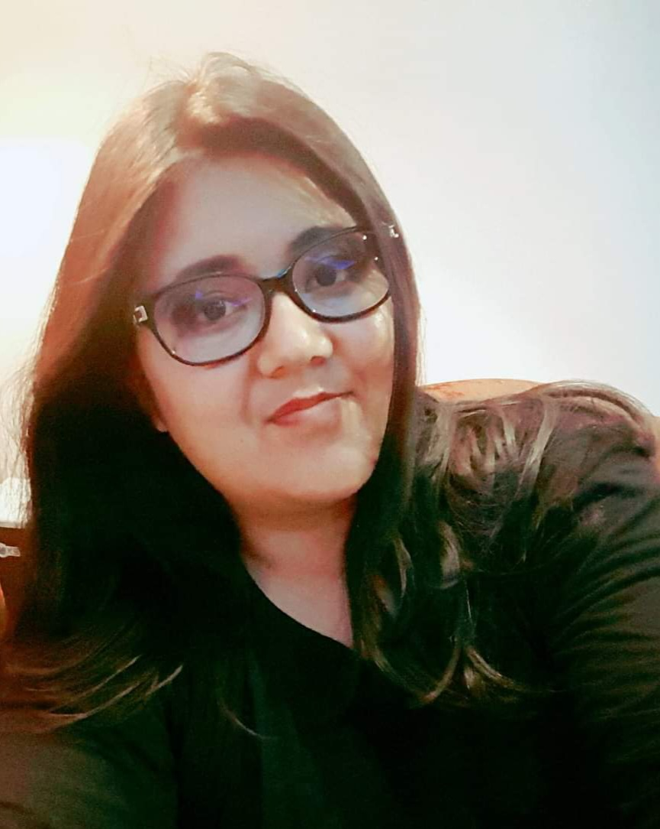
Designation: Assistant Professor in English
Area of specialization: M.Phil.in English
Eliezer Joldan Memorial College, Leh
Email:sonamangmo.88@gmail.com
Phone:9906993222

CV Summary

- M.Phil.in English, SET.
- Attended 20 regional, national and international workshops/ seminars/ conferences.
- 7 years teaching experience.
- Research interests: Ladakhi Fairy Folktales, Himalayan studies, Gender Studies.

Awards and Achievements

- MA ENGLISH Gold Medalist
- Published 10 articles and short story in regional newspapers, magazines and online international journal.

Workshops, Seminars, Symposia and Conferences attended

WORKSHOPS ATTENDED:
Attended 4 regional and national workshops.
- Workshop on essential computing techniques held on Oct 8 to 10th 2014 at Central university of jammu

- Workshop on scholarly writing and plagiarism: key concerns held from 29th- 31st Oct, 2014 at Central university of jammu

- Workshop on Digital India held on 5th March 2016 at Central university of jammu

- Attended a Creative Writers Workshop organised by the Dara Shikoh Foundation in Feb 2017

SEMINARS/CONFERENCES ATTENDED:
- Presented a paper in the 6th international seminar on the republic in Shakespeare held from 16-18 Oct 2013
- Presented a paper in national conference on next generation leadership in India held on 22-23 Nov 2013
- Participated in the 13th international melow conference on literature in the age of information technology on 21-23 Feb 2014
- Presented a paper in a 2 day national seminar on Feminist Transitions held on March 24-25, 2014
- Presented a paper in a 2 day national seminar on cultural and literary responses to the 1st world war held on 3- 4 Sep 2014.
- Presented a paper entitled "Women , Marriage and Dowry practice in Ladakh ", in a national seminar on Gender at Central university of Jammu on 28th Oct 2014
- Participated in a national seminar on Translation Studies held on 21st Jan 2015
- Presented a paper on Gender based violence in an international conference organised by Melow Chandigarh on 20- 22 Feb 2015
- Presented a paper on 21st April 2015, on the topic: Renunciation and nuns in a one day national seminar on politics of gender.
- Participated in a two day national seminar at University of Kashmir on Revisiting Literary Classics in the Post Modern Secular World held from 21st to 22nd Oct 2015
- Recently, presented a paper in a national seminar organised by the Department of Women's studies at University of Jammu held on March 20- 21, 2017
- Presentation titled ‘How to improve Language Proficiency’ at EJM College Leh, November 2019
- Attended 1 Yoga and 1 Finance theme based seminar in the year 2020
- 1 WEEK FDP organized by Tata Institute of Social Sciences at University of Ladakh in July 2021.
- International seminar on Gender and Precarity organized at SMVDU, Katra, in March 2023.
- NEP FDP organized by IGNOU in April 2023.

Research Publications : 4 (total)

ACADEMIC QUALIFICATIONS:

- B.A Hons. English, Lady Shri Ram College, University of Delhi.
- Masters and M.Phil. in English, Central University of Jammu.

Research Experience

Research stage | Title of Work/ Thesis | University where the work was carried out | Year
M.Phil. or equivalent | Nuns' Life Narratives: Poetics of Marginalization in Kim Gutschow's Being a Buddhist Nun: The Struggle for Enlightenment in the Himalayas and Sarah Joseph's Othappu. | Central University of Jammu | 2015
Ph.D. (Currently Enrolled) | Ladakhi wedding songs and folk narratives. | Shri Mata Vaishno Devi University Katra, J&K | Enrolled
Training (Please specify) | 1 Orientation Course and 2 Refresher Courses attended | University of Jammu, University of Delhi | 2017, 2019, 2023

